Valeria Guzmán-Verri
Universidad de Costa Rica

Jiménez-Fonseca, Hernán (b. 1942)

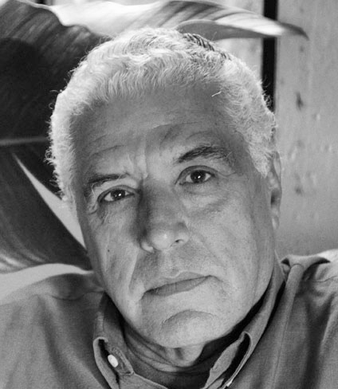

Hernán Jiménez-Fonseca
http://revistas.ucr.ac.cr/index.php/revistarquis/article/view/1290/1353

Costa Rican architect Hernán Jiménez-Fonseca obtained his degree at the Universidad Autónoma de Mexico (UNAM) in 1970. Like many Costa Rican architects of his generation, he trained abroad since there were no architecture degree courses in the country until 1971. After settling back in Costa Rica he designed the National Bank Agency in Puriscal, which was built in 1973. But it was in 1976, when he won the competition for the Costa Rican Association of Engineers and Architects building that there came a turning point in his career. With its monumental concrete structure and distinctive form, the building became a significant reference in Costa Rican architecture. Throughout his career, and alongside his designs for residential, religious, and institutional architecture (Pinares Apartment Block, 1980; Turrialba Catholic Church, 1999; Fire Station in Puriscal, 1982), Jiménez-Fonseca won a number of important competitions, such as the National Assembly in 1991 (un-built) and the National Center for Culture in 1994. He was also a member of the Jury for high-profile urban projects such as the Square for Democracy. As a competition-winner and jury-member, Jimenez Fonseca left a lasting and influential mark on the urban setting of the country’s capital.

A further aspect of Jiménez-Fonseca’s valuable contribution to Costa Rican architecture is his long-standing effort to enhance its academic culture. In 1975, he became part of the first School of Architecture at the University of Costa Rica, holding the post of professor from 1997 until his retirement in 2005. His teaching focused on the language of section, plan, and facade as a means of structure and volume design. He was also particularly attentive to a certain ‘truth-to-materials’ ethos (his architecture is chiefly composed of exposed concrete and brick) and to the organization of spatial qualities in terms of firmness, robustness, and stability.

List of works
1973 Bank Agency, Puriscal, Costa Rica
1976 Costa Rican Association of Engineers and Architects, San José, Costa Rica
1980 Apartment Block, San José, Costa Rica
1982 Fire Station, Puriscal, Costa Rica
1985 Bank Agency, Alajuela, Costa Rica
1994 National Center of Culture, San José, Costa Rica
1999 Catholic Church, Turrialba, Costa Rica

References and further reading

Fonseca, E. et al. (1998) Historia de la Arquitectura en Costa Rica, San José: Fundación Museos del Banco Central de Costa Rica.

Sanou, O. (2010) Costa Rica: An architectural and Landscape Guide, San José and Sevilla: Junta de Andalucía, Consejería de Obras Públicas y Vivienda, Colegio Federado de Ingenieros y Arquitectos de Costa Rica.

Jiménez-F. H. (2011). Edificio del Colegio Federado de Ingenieros y de Arquitectos. RevistArquis 1(1): Universidad de Costa Rica.

Visual Material

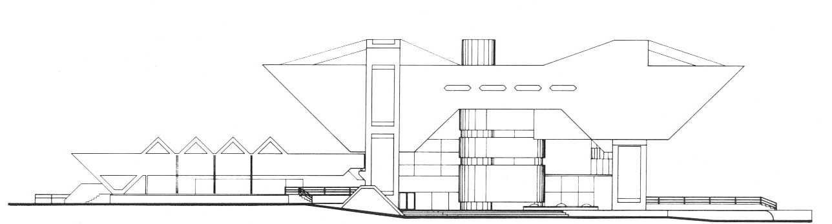

East side elevation, Drawing. Costa Rican Association of Engineers and Architects, 1976.
Copyright: http://revistas.ucr.ac.cr/index.php/revistarquis/article/view/1290/1353

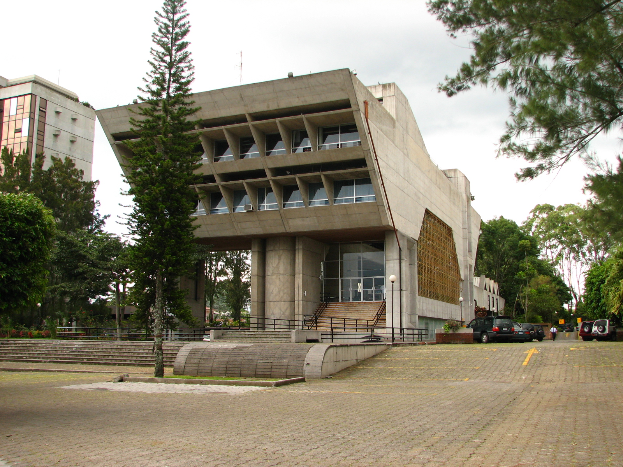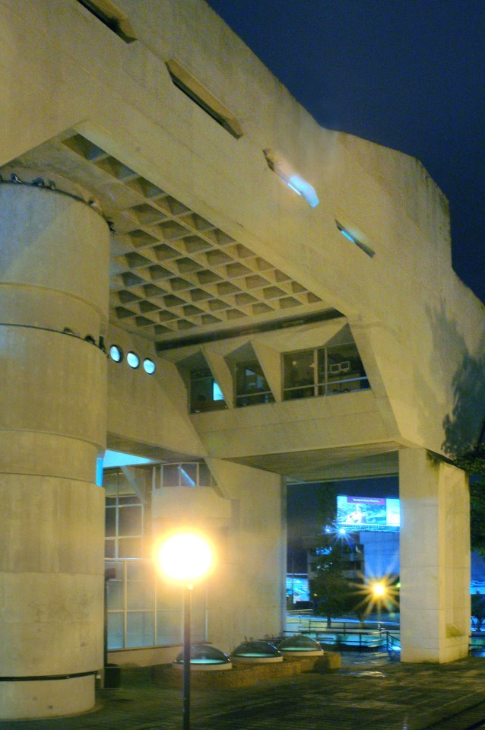

Front and Back view. Costa Rican Association of Engineers and Architects, 1976.
1.Not in copyright: http://en.wikipedia.org/wiki/Colegio_Federado_de_Ingenieros_y_Arquitectos_de_Costa_Rica
2. Copyright: Archive of Hernán Jiménez

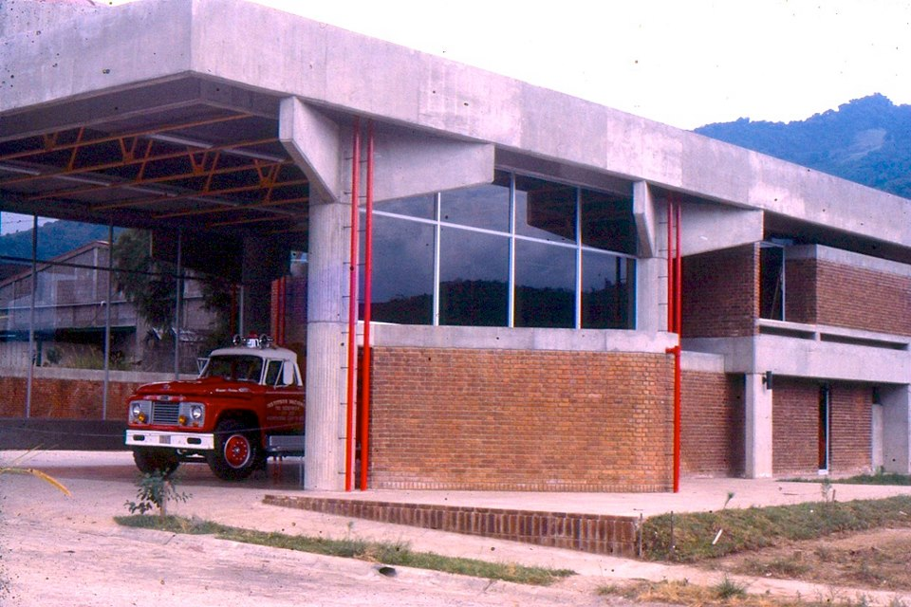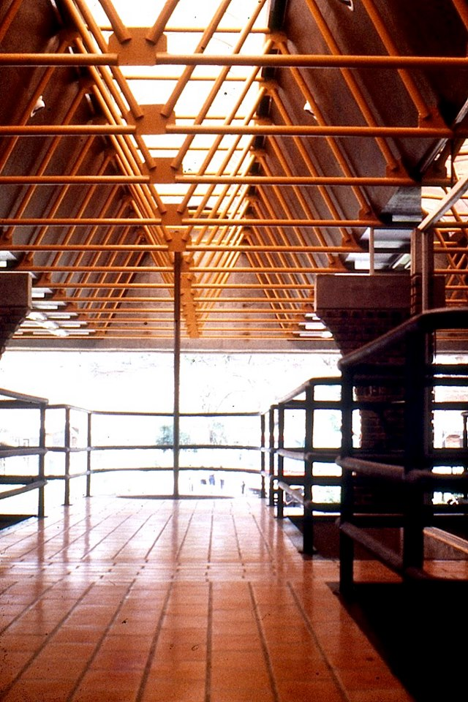
Front and Interior View. Fire Station in Puriscal, Costa Rica. 1982.
Copyright: Archive of Hernán Jiménez

